Term of Reference for a 25-30 kWp Phovoltaic structure design (Multi Functional Solar Platform - MSP), for Plan International project " Light Up your Future’: Socio-economic Empowerment of Young Refugees in Sudan through Sustainable Energy Solutions, funded by the Islamic Development Bank.

INDEX
1. INDEX 1
2. Organization Background 1
3. Project Background: 1
4. Objective of the Task 2
5. Plan International Sudan Responsibilities: 3
6. Consultant Activities and Responsibilities: 3
7. Expected Consultant Deliverables 3
8. Consultant Profile 3
9. Submission Information: 3
10. Data Confidentiality and Privacy and Safeguarding of children and young people 4
11. Annexes 4

Organization Background
Plan International is an independent child rights and humanitarian organization committed to children living a life free of poverty, violence and injustice. We actively unite children, communities and other people who share our mission to make positive lasting changes in children’s and young people’s lives. We support children to gain the skills, knowledge and confidence they need to claim their rights to a fulfilling life, today and in the future. We place a specific focus on girls and women, who are most often left behind. We have been building powerful partnerships for children for more than 75 years, and are now active in more than 70 countries. In Sudan, Plan operates in four states which are White Nile, North Kordofan, Kassalla and North Darfur. The assessment is to be conducted in White Nile South Sudanese Refugees camps and host communities in Al Salam locality, with focus on Al Redis 2 camp.

Project Background:
The current crisis in South Sudan (SSD) started in Dec. 2013 and affects the South Sudanese population. The project focus on refugees displaced to White Nile state in Sudan particularly refugees in Al Redis 2 and the host community.
The project intends to create employment and self-employment opportunities for the refugees affected by the Conflict in South Sudan and other nearby countries, by providing with capacity building trainings and the development of Income Generating Activities based on renewable Energy solutions such as a Multifunctional Platform, object of this tender, and a solar oven which will be installed by the project.
The project is designed around three Expected Results - each representing a thematic component, which complements the following:
- Component 1: Capacity Building and Skills Development
- Component 2: Renewable Energy–Based Income Generating Activities
- Component 3: Sustainability and Scale-up Facilitation
Project Objective: This project contributes to improving the socio-economic situation of youth (males and females) living in host communities and refugee camps in Sudan through capacity and skills development and through enhancing their access to clean, modern, reliable and sustainable energy for income-generating activities (IGAs)
- Outcome 1: Readiness of marginalized youth enhanced by improving their competencies (skills, knowledge and practices) to engage in sustainable livelihood activities in renewable energy
- Outcome 2: The economic productivity of marginalized youth improved to contribute to the economic wellbeing of themselves, families and the community
- Outcome 3: Improvements in the sustainability of new and existing renewable energy livelihoods project.
Beneficiaries: 60 youth (50% women) will benefit from training opportunities, direct employment opportunities and livelihood opportunities for self-employment and micro-businesses (Please see Annex 1 for more information).

Objective of the Task
The main purpose of this assignment is to detail design a Photovoltaic structure (called Multi-Functional Solar Platform - MSP) that will be installed in Alagaya refugee camp. This Multi Solar Platform will be used to provide a sustainable energy supply for the Revenue and Income Generating Activities that will be developed around them.
The intention is to use the MSP mainly to produce flour through milling grains and sorghum which are distributed raw by World Food Program. The flour produced will then be used for the production of bread through the activity of Solar Ovens.
In addition, the MSP will be a renewable energy generator for feeding other types of economic activities that may be developed by all community members and, consequently, to strengthen their families' economic security. The MSP location will also serve for other purposes:
- as a training center and demonstration model of Renewable Energy-based RGAs for mentoring and replication
- showroom to sell/renting Renewable Energy kits for domestic or productive users.
This way, all the community will always have the possibility to buy one solar kit (solar home systems (SHS), lantern, etc.) to run their own business and also the non-productive users can be covered.
The detail design will be based on the information produced from a preliminary study that will provide a market assessment which shall show market opportunities for the Income Generating Activities, as well as an energy demand assessment based on the market findings and the beneficiary’s preferences. Initial estimation is of a 25-30 kWp system.
The system concepts will have to consider the following:
- Power capacity adapted to the demand of:
  - The milling infrastructure.
  - Other Income Generating Activities that will be defined in the previous assessment.
- Design should also consider:
  - Must be adapted to the location that will have already been selected in order to ensure the security of the infrastructure and its users, and easy access to the market.
  - Must provide space for:
    - A training center and demonstration model of Renewable Energy-based RGAs for mentoring and replication.
    - A showroom to sell/renting Renewable Energy kits for domestic or productive users.
  - The technical specifications will allow the supply and installation of MSP in order to deliver a continuous and reliable service in the locality targeted by the project, and will consider the following basic principles: (i) reliability of equipment, (ii) optimization of operating and maintenance conditions to take climatic conditions into account.
  - The design will consider an installation in an isolated place with few qualified personnel in the mechanical and electrical fields. Resistant material is therefore required, both for the main components and for the mounting accessories, in order to require the lowest possible maintenance and to resist corrosion and long-term degradation.
  - Climatic characteristics have to be considered for the sizing of the components.
  - The equipment designed will be sized to deliver the daily energy indicated for the site under the reference climatic conditions corresponding to a profile of a "typical day".
  - The MSP design (including all components) must comply with international electrical safety standards, laws and regulations. The MSP and its components must comply with the most stringent IEC standards for solar photovoltaic system equipment and design.
- The task will have to provide all the necessary documents (narrative, drawings, technical specifications, list of materials) for one single solution for the Multi Solar Platform containing: technical specifications that will be required for all the components (panels, inverters, wiring, batteries, other required electrical components, buildings and other required infrastructure). It will have to consider the proper power and connection of all the systems detailed in the preliminary market and energy demand assessment, and include the most efficient and sustainable solutions. The design will have to include all the necessary detailed information for an independent company to then perform the procurement and installation of the MSP.
- It’s strongly recommended for the applicants to visit the site and its surroundings and to obtain by themselves and at his own risk all the information which may be necessary for the preparation of the design; the costs related to these visits are the responsibility of the applicants.

Plan International Sudan Responsibilities:
- Arrange and manage negotiations with the government and other implicated actors such us the UNCHR for the location of the MSP and other logistics aspects.
- Provide the consultant team all the relevant project information, including the preliminary market and energy demand assessment.
- Project Manager & YEE lead, MEAL Coordinator and Plan International Spain will be involved in all assessment process to ensure that this exercise meets the project’s objective.

Consultant Activities and Responsibilities:
The consultant key activities will include but not be limited to the following:
- Desktop review and analysis of the relevant data/information related to the preliminary study previously performed.
- Submission of a draft design and finalize it based on comments and inputs from Plan International.
- Submission of final design.

Expected Consultant Deliverables
- Quality documents (Narrative, Drawings, Technical specifications, List of materials) for one single solution for the Multi Solar Platform.

Consultant Profile
- At least experience in 2 similar jobs of Solar Platform designs related to renewable energy based IGAs (to be demonstrated with documentation).
- Familiarity with White Nile State especially refugee’s business community.
- Excellent networking skills.
- Excellent knowledge of gender equality and protection issues.
- Excellent communication skills.
- Gender balanced team.

Submission Information:
Interested candidates are invited to submit via email one (1) application package to Operation Support Service Department via Ahmed.Ibrahim@plan-international.org
- CV in English which clearly states relevant expertise/experiences;
- 1 technical proposal including detailed work-plan and methodology, including but not limited to:
  - Techniques and tools used to collect, prepare and analyze information and data, including software used.
- 1 financial proposal, which shall include consultants’ fees as well as all other costs related to the design (transportation and accommodation if needed, etc).
Only shortlisted candidates will be contacted for further steps.

Data Confidentiality and Privacy and Safeguarding of children and young people
The Consultant undertake to respect and protect the confidentiality of all information acquired as a result of or pursuant to this Term of Reference and will not, without the other Plan International prior written consent, disclose any such information to a third party, unless it is required to do so by any applicable law or regulation or is specifically authorized, Plan International must comply with Applicable Law and implement any additional policies or procedures as required. Moreover, other Plan International policies impose additional requirements regarding the collection, use, and protection of particular classes of Personal Data, including the requirements described in the Global Policy Safeguarding Children and Young People.
The Consultant must read, sign on and apply Global Policy Safeguarding Children and Young People in all the process of this study, as well as the Anti-fraud policy.

Terms of Payment
Plan international Sudan shall pay the consultancy fee to the consultant as agreed between both the parties by contract agreement in USD
p. All expenses shall also be included in the contract agreement. Initial payment of 30% will be made upon the signature of this agreement with detailed work plan approved by Plan international- Sudan, the remain being paid upon the delivery of the completion of all previously outlined activities.

Annexes
- Project Proposal

- Project Log frame work

- Plan Child Protection Policy

- Best Interest Assessment (BIA)

- Similar design examples

Annex 5. Similar design example.

Following is an example of a similar design used in another Plan International project used also to power Income Generating Activities and for solar energy solutions commercialization. This example is shown for concept reference (size might be different).

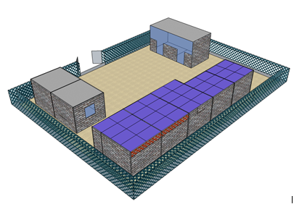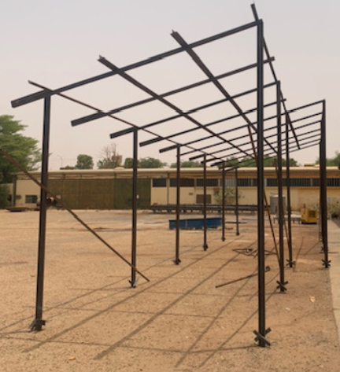
Solar panels
Space underneath might be used for Income Generating Activities.

Fence around the infrastructure might be necessary for security reasons. To be considered for the design.

Data Privacy Policy, Plan International, March 2018.
Global Policy Safeguarding Children and Young People, Plan International, November 2017.

